

Faculty of Engineering (Degree)
Semester – 1
Subject Name – Programming for Problem Solving
Subject Code – BE200104
Faculty Name – Ashwini Walake
Unit -2: Basic of C programming

Introduction to ‘C’ Language:
C language facilitates a very efficient approach to the development and implementation of computer programs.
C was first designed by Dennis Ritchie for use with UNIX on DEC PDP-11 computers.
Applications of C:
C is widely used in various domains, including:
- Operating Systems:
Kernels of operating systems like UNIX, Linux, and Windows are largely written in C.
- Embedded Systems:
Due to its efficiency and low-level control, C is a popular choice for programming microcontrollers and embedded devices.
- System Programming:
Compilers, interpreters, device drivers, and utility programs are often developed using C.
Core Features of C
- Fast and Efficient: Programs compile directly into native machine code without the overhead of an interpreter or virtual machine.
- Middle-Level Language: Combines the direct hardware access of low-level assembly with the readable syntax of high-level languages.
- Statically Typed: Variable data types are validated during compilation rather than execution, preventing runtime type errors.
- Pointer Support: Provides direct access to system memory addresses, enabling highly efficient array manipulation and structure routing.
- Manual Memory Management: Allows dynamic runtime allocation and deallocation using malloc(), calloc(), and free().
- Low-Level Access: Enables explicit bit-wise operations to manipulate registers, making it ideal for systems programming.
- Procedural Approach: Executes logic sequentially through a series of step-by-step instructions and user-defined functions.
- Modular Structure: Codebases can be divided into smaller modules and standalone files that compile independently.
- Rich Standard Library: Includes built-in functions via header files (like <stdio.h> or <math.h>) for handling input/output and math.
- Portability: Source code can compile and run across different operating systems like Linux, Windows, or macOS with minimal updates.
- Case Sensitive: Treats lowercase and uppercase characters differently (e.g., Value and value are unique variables).
- Extensible: New functions, external modules, and custom tools can be integrated seamlessly into preexisting codebases
Basic Structure of C Language:
The program written in C language follows this basic structure. The sequence of sections should be as they are in the basic structure. A C program should have one or more sections but the sequence of sections is to be followed.
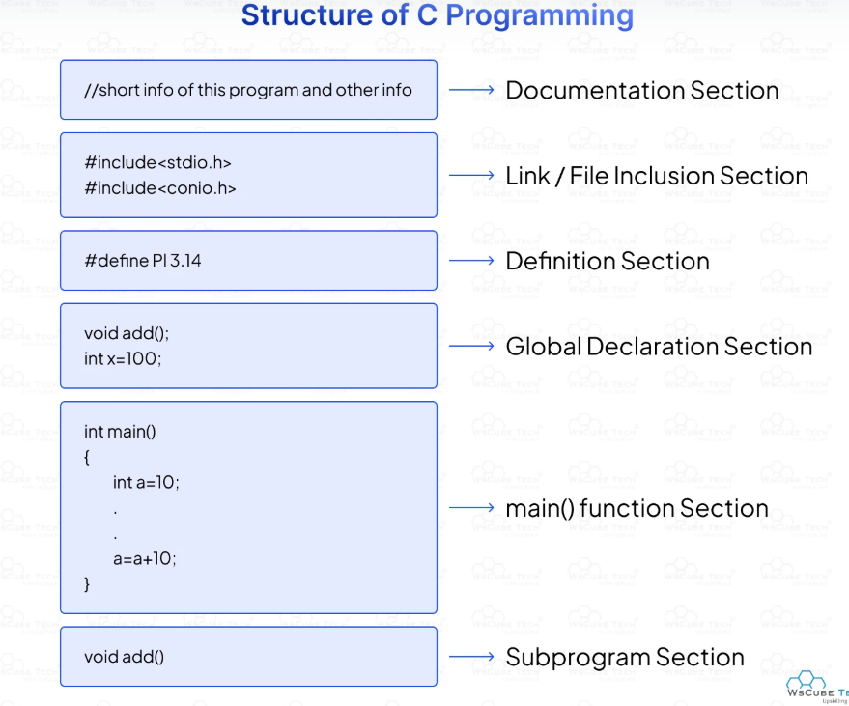
1. DOCUMENTATION SECTION : comes first and is used to document the use of logic or reasons in your program. It can be used to write the program's objective, developer and logic details.
The documentation is done in C language with /* and */ . Whatever is written between these two are called comments.
2. LINKING SECTION : This section tells the compiler to link the certain occurrences of keywords or functions in your program to the header files specified in this section.
e.g. #include <stdio.h>
3. DEFINITION SECTION : It is used to declare some constants and assign them some value.
e.g. #define MAX 25
Here #define is a compiler directive which tells the compiler whenever MAX is found in the program replace it with 25.
4. GLOBAL DECLARATION SECTION : Here the variables which are used through out the program (including main and other functions) are declared so as to make them global(i.e accessible to all parts of program)
e.g. int i; (before main())
5. MAIN FUNCTION SECTION: It tells the compiler where to start the execution from main()
{
point from execution starts
}
main function has two sections
1. declaration section : In this the variables and their data types are declared.
2. Executable section : This has the part of program which actually performs the task we need.
6. SUB PROGRAM OR FUNCTION SECTION : This has all the sub programs or the functions which our program needs.
SIMPLE ‘C’ PROGRAM:
/* simple program in c */
#include<stdio.h>
main()
{ printf(“welcome to c programming”); } /* End of main */
Character Set:
The character set in C programming refers to the entire collection of valid characters, symbols, and blank spaces that a compiler can recognize and interpret. These characters serve as the foundational building blocks for forming constants, variables, expressions, and formatting program text.
1. Alphabets
C supports standard English letters. It is entirely case-sensitive, meaning uppercase and lowercase options are evaluated as separate characters.
- Uppercase: A to Z
- Lowercase: a to z
2. Digits
Numerical values in calculations or declarations utilize base-10 digits.
- All numeric units: 0, 1, 2, 3, 4, 5, 6, 7, 8, 9
3. Special Characters
C relies on mathematical, conditional, and punctuation symbols for syntax rules and mathematical evaluations.
- Operators and delimiters:
- , (comma)
- . (period/dot)
- ; (semicolon)
- : (colon)
- ? (question mark)
- ' (single quote)
- " (double quote)
- ! (exclamation mark)
- _ (underscore)
- +, -, *, /, % (arithmetic operators)
- <, >, =, &, |, ^, ~ (relational and bitwise operators)
- ( ), [ ], { } (brackets and parentheses)
4. White Space Characters
White spaces separate keywords, variables, and expressions to maintain logical structures. The compiler ignores most formatting spaces during tokenization, except inside literal strings.
- Blank Space: Used to separate program commands.
- Horizontal Tab (\t): Indents chunks of logic.
- New Line (\n): Moves the cursor down.
- Carriage Return (\r): Resets the line position
C-TOKENS : Tokens are individual words and punctuations marks in English language sentence. The smallest individual units are known as C tokens.

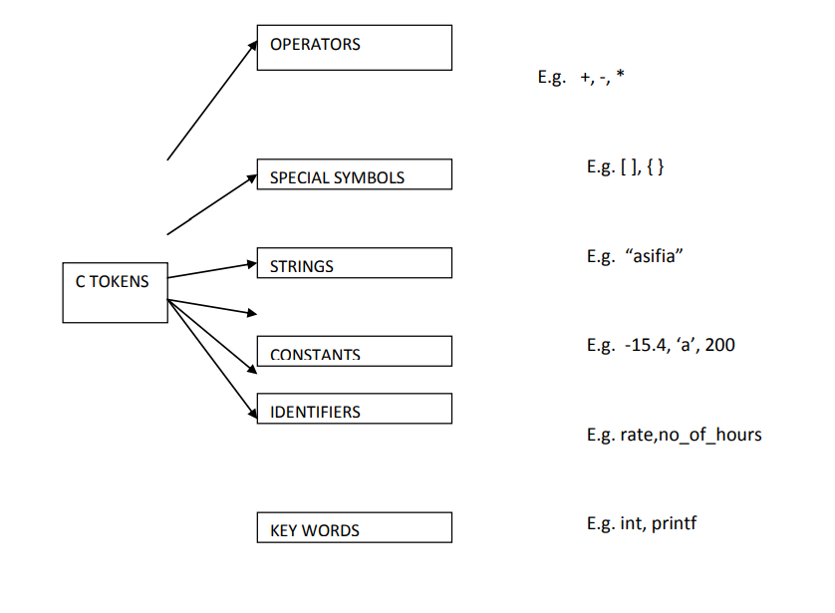
Keywords :
There are certain words, called keywords (reserved words) that have a predefined meaning in ‘C’ language. These keywords are only to be used for their intended purpose and not as identifiers.
The following table shows the standard ‘C’ keywords
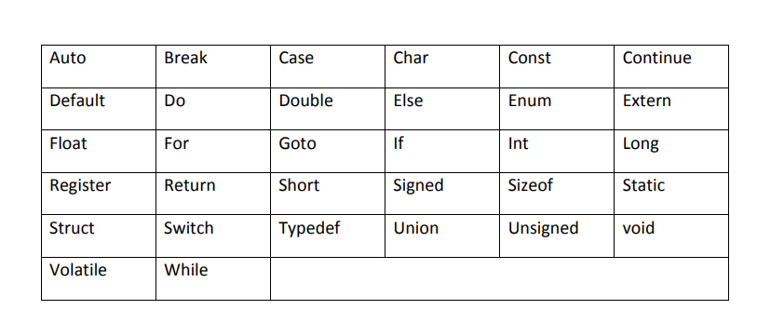
Identifiers :
Names of the variables and other program elements such as functions, array,etc,are known as identifiers.
There are few rules that govern the way variable are named(identifiers).
1. Identifiers can be named from the combination of A-Z, a-z, 0-9, _(Underscore).
2. The first alphabet of the identifier should be either an alphabet or an underscore.
digit are not allowed.
3. It should not be a keyword.
eg
1)float a, b, c;
2)int e, f, grand total;
3)char present_or_absent;
Assigning Values :
When we name and declare variables we need to assign value to the variable. In some cases we assign value to the variable directly like
a=10;
in our program.
Constants :
A quantity that does not vary during the execution of a program is known as a constant supports two types of constants namely Numeric constants and character constants.
1)Numeric Constants:
1. Example for an integer constant is 786,-127
2. Long constant is written with a terminal ‘l’or ‘L’,for example 1234567899L is a Long constant.
2)Character Constants:
A character constant is written as one character with in single quotes such as ‘a’.
The following are the some of the examples of escape sequences:
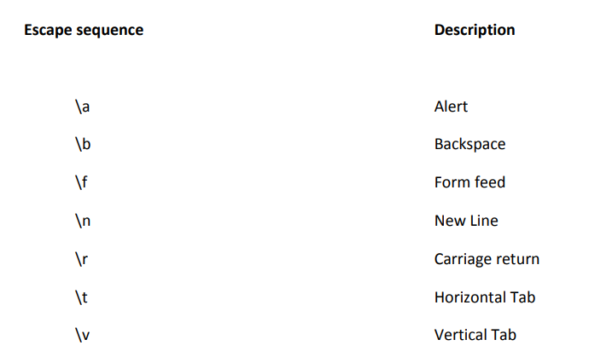
Variables :
Variable is a name given to a memory location where we can store different values of the same datatype during the program execution.
Rules to specify a variable name...
• Variable name should not start with a digit.
• Keywords should not be used as variable names.
• A variable name should not contain any special symbols except underscore( _ ).
• A variable name can be of any length but compiler considers only the first 31 characters of the variable name.
Declaration of Variable :
Declaration of a variable tells the compiler to allocate the required amount of memory with the specified variable name and allows only specified data type values into that memory location.
Declaration Syntax:
datatype variable_name;
Example: int number;
The above declaration tells to the compiler that allocates 2 bytes of memory with the name number and allows only integer values into that memory location. Assigning values to variables Assigning a value to variable at the time declaration is called initialization .
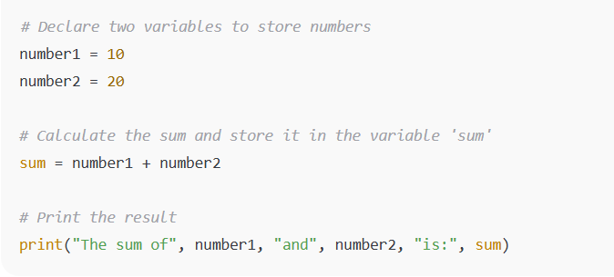
Data Types :
To represent different types of data in C program we need different data types. C supports four different classes of data types namely
1. Basic Data types
2. Derives data types
3. User defined data types
4. Pointer data types
1) Basic Data Types:
All arithmetic operations such as Addition , subtraction etc are possible on basic data types.
E.g.: int a,b;
Char c;
The following table shows the Storage size and Range of basic data types:
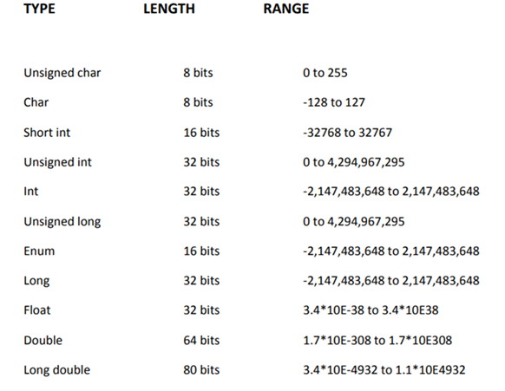
2) Derived Data Types:
Derived datatypes are used in ‘C’ to store a set of data values. Arrays and Structures are examples for derived data types.
Ex: int a[10];
Char name[20];
3) User Defined Datatypes:
C Provides a facility called typedef for creating new data type names defined by the user. For Example, the declaration ,
typedef int Integer;
“typedef” is more useful with structures and pointers.
4) Pointer Data Types:
Pointer data type is necessary to store the address of a variable.
Example:
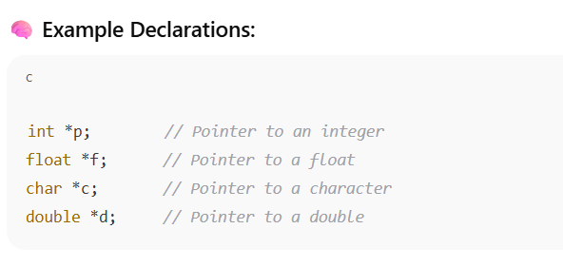
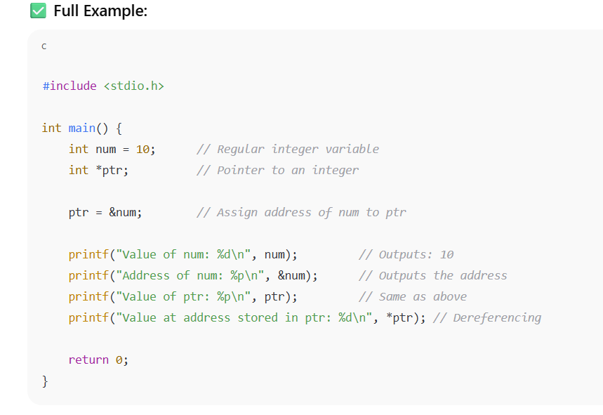
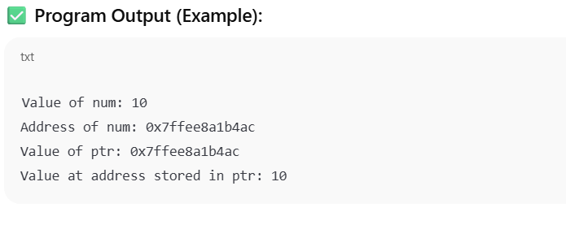
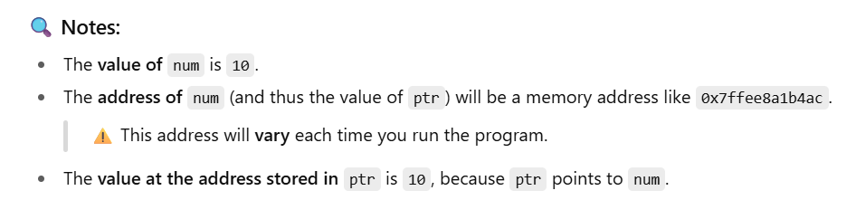

Input and Output Statements :
In C programming, input and output (I/O) functions are provided by the standard library <stdio.h> to handle data transfer between a program and devices like the keyboard or screen. These functions are divided into two main categories: Formatted I/O functions (which use format specifiers like %d or %c to structure data) and Unformatted I/O functions (which process raw bytes or single characters directly).
Unformatted I/O Functions:
The simplest of input operator is getchar to read a single character from the input device.
varname=getchar();
you need to declare varname.
The simplest of output operator is putchar to output a single character on the output device. putchar(varname) The getchar() is used only for one input and is not formatted.
Formatted I/O Functions:
These functions allow you to read and write data in specific formats using predefined format specifiers.
printf() (Output)
- Purpose: Displays text, variables, or expressions on the screen.
- Syntax: printf("format_string", variable1, variable2);
- Example:
c
int age = 25;
printf("Age is %d\n", age); // Outputs: Age is 25
scanf() (Input)
- Purpose: Takes user input from the keyboard and maps it to variables.
- Crucial Rule: You must pass the memory address of the variable using the ampersand (&) operator so scanf() knows where to store the data.
• Syntax: scanf("format_string", &variable);
Example:
int score;
scanf("%d", &score); // Reads an integer from the user
Common Format Specifiers
- %d — Integer (int)
- %f — Floating-point number (float)
- %c — Single Character (char)
- %s — Sequence of characters (string)

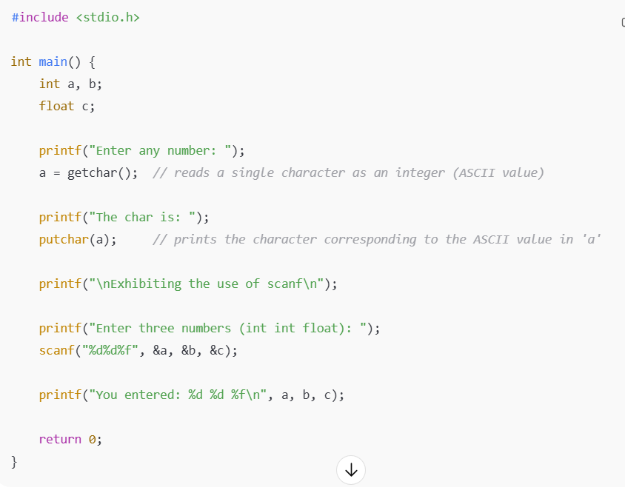
Coding Standards and best practice in C programming:
Writing high-quality C code requires strict formatting, memory safety, and robust error handling to counteract the language's lack of automatic safeguards.
Naming Conventions & Code Style
- Descriptive Variables: Use meaningful names instead of cryptic single characters.
- CamelCase / snake_case: Choose one name style and apply it universally.
- UPPERCASE Macros: Define all #define constants and macros in block capitals.
- Fixed-Width Types: Prefer <stdint.h> types like uint32_t over unpredictable int types.
- Line Limits: Limit your source lines to 80 or 100 characters maximum.
- Brace Consistency: Follow a specific bracing style, such as K&R or Allman.
- Single Assignments: Do not embed variable assignments inside conditional evaluations.
Memory Management & Safety
- Check Allocations: Always check if malloc() or calloc() returned NULL.
- Free and Nullify: Free pointers immediately after use and set them to NULL.
- Prevent Overflows: Use bounded functions like snprintf() instead of hazardous sprintf().
- Size Tracking: Always pass array sizes alongside array pointers to your functions.
- Arrow Operator: Use p->member instead of manual dereferencing like (*p).member
Error Handling & Control Flow
- Return Values: Verify the return statuses of file I/O operations and system calls.
- No Magic Numbers: Substitute unexplained numeric literals with named constant expressions.
- Ban Goto Statements: Avoid using goto statements unless managing centralized cleanup functions.
- Switch Fail-safes: Provide an explicit default block inside every switch construct.
- Header Guards: Protect all header files against double inclusion using #ifndef guards.
Documentation & Portability
- Comment the "Why": Document architectural decisions and tricky edge cases, not obvious logic.
- Modern Standards: Target modern specifications like C99 or C11 over obsolete C89.
- Initialize Variables: Initialize automatic variables immediately upon declaration.
- Const Correctness: Apply the const qualifier to pointers when data should remain read-only.

